Guidance on Supporting Menopause

Enfield 2022

Author and date of first publication | Reviewed by | Date of last review | Date of next review
Public Health/HR
October 2022

Contents

1. Introduction 3
2. Scope 4
3. What is the Menopause? 4
4. Symptoms of the Menopause 5
5. Roles & Responsibilities 7
6. Legislative Compliance 8
7. Trans People and the Menopause 8
8. Risk Assessments 9
9. Flexible Working Hours 9
10. Resources and Links to Further Information and Support 10
Appendix 1: Managers Guidance For Supporting Employees 11
Appendix 2: Menopause & Lifestyle 13

Enfield Council recognises that the menopause can be an issue in the workplace and staff need support. We encourage staff to talk openly, positively and respectfully about the menopause. The council is committed to actively support and inform our workforce affected by the menopause.

Introduction

Menopause is a very personal experience and can affect people at work in various ways The most important and valuable thing managers and colleagues can do is listen and respond sympathetically, providing practical support wherever possible (e.g., flexible working arrangements). This support can make a difference in dealing with the symptoms and working well and productively with the menopause.

  - This guidance is intended to raise awareness of the menopause and provide information and support for employees - both those who are directly affected and those indirectly affected, for example, partners, colleagues, or line managers.

  - The purpose of this guidance is also to assist line managers in supporting staff going through the menopause in the workplace. It recognises that staff may need additional consideration, support, and adjustments during the time of change, before, during and after the menopause (the stages of the perimenopause, menopause then post menopause).

  - Enfield Council is committed to ensuring that all individuals are treated fairly and with dignity and respect in their working environment. It is also committed to ensuring the health, safety, and wellbeing of the workforce. Enfield Council will work proactively to make adjustments where necessary to support staff experiencing the menopause. The Council seeks to eradicate any exclusionary or discriminatory practices in respect of age, sex, disability, race, religion or belief, marriage and civil partnership, pregnancy and maternity, sexual orientation, and gender reassignment.

  - Enfield council recognises the need to retain valuable talent within the workforce by supporting staff through the menopause. Enfield’s workforce is 3715 strong, of which 2326 (62%) are female and of the 2326, 1394 are over the age of 45 (March 2022). The council wants all employees to understand menopause and that it is no longer considered a ‘taboo’ subject. Menopausal employees should feel confident and comfortable to discuss any related health problems with their line manager, Human resources, the Employee Assistance Programme (EAP), Occupational Health (OH) and for necessary support to be in place. Employees must also be assured that any discussions will be treated confidentially.

  - The menopause is a natural stage of life experienced by most women and can temporarily impact upon a number of areas of an employee’s wellbeing and work performance. The potential negative impact of symptoms on the individual and the organisation, such as reduced job satisfaction and productivity and/ or higher sickness absence, often occur when employees ‘suffer in silence’.

  - The council recognises that a large proportion of our employees will be working through and well beyond the menopause. In the UK it is estimated that around 1 in 3 women are either currently going through or have reached the menopause. The menopause affects all women, and it can often indirectly affect their partners, families, and colleagues as well.

Scope

2.1 This guidance applies to all employees with the following exceptions:
- Staff employed to work in schools where, by law, such matters are under the control of the Governing Body.
- Agency workers - refer to the Principles of Managing Agency Workers.
- Casual workers – refer to the Principles of Managing Casual Workers

What is the Menopause?

  - Menopause is a natural part of the ageing process for a woman, sometimes referred to as ‘the change’. It refers to the point in time when menstruation has stopped for twelve consecutive months and a woman has reached the end of her reproductive life. After a woman has not had a period for a year, she can be described as ‘post-menopausal’.

  - The menopause usually occurs between the ages of 45 and 55, however, many women experience the menopause before 45 (early menopause) and a significant number of women before the age of 40 (premature menopause). Early menopause is not the same as perimenopause, early menopause is when a woman’s periods stop before the age of 45, either naturally or as a result of side effect from certain treatments. Menopause symptoms may also be brought on by hormonal treatment for example for breast cancer.

  - Women from the BAME community can enter perimenopause (where the body prepares for menopause) and menopause around 2 years earlier than their white counterparts and tend to have longer transitions periods and suffer more intense symptoms, that can increase with age.

  - It should be noted that people from the non-binary, trans and intersex communities may also experience menopause symptoms, although for various reasons their experience may be different. (please see Section 7)

  - Experiences and perceptions of the menopause may also differ in relation to disability, age, race, religion, sexual orientation, or marital/civil partnership status. It is important to recognise that for many reasons, individual experiences of the menopause may differ greatly.

  - Perimenopause is the time leading up to menopause when a woman may experience changes, such as irregular periods or other menopausal symptoms. This often last for four to five years although for some women it may continue for many more years or for others last just a few months.

  - During the time of the peri-menopause women may begin to experience symptoms due to changes in their hormone levels. These vary in degree between different women from mild to highly significant. As they may still be having regular periods at the onset of symptoms, many women do not recognise what is causing their symptoms. This can be a barrier to accessing support.

Symptoms of the Menopause

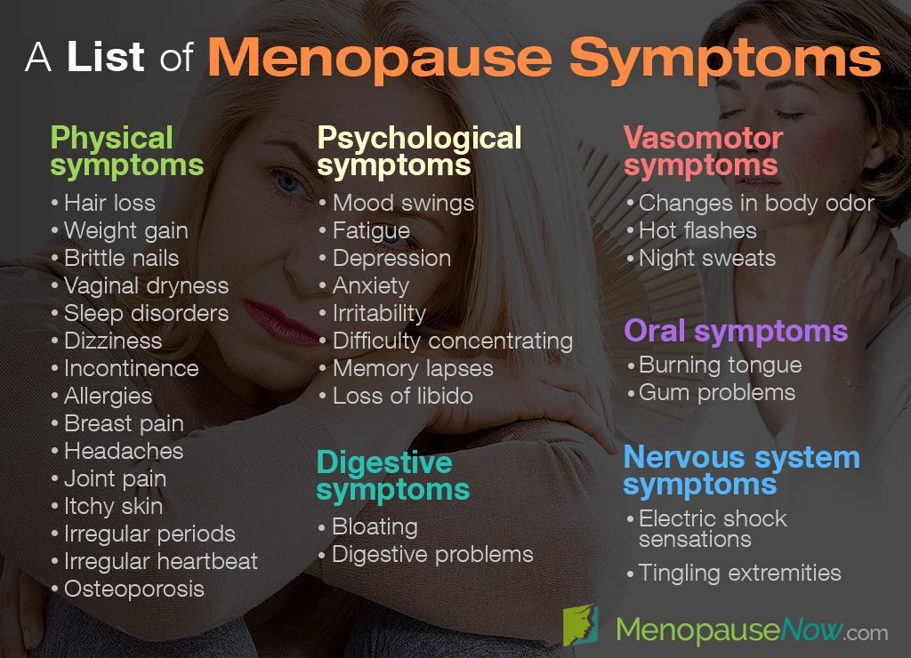

  - Symptoms can manifest both physically and psychologically. The symptoms can vary with each person going through the menopause and may not be experienced on an ongoing basis. Symptoms can include.

- Hot flushes (brief and sudden surges of radiating heat usually felt in the face, neck and chest)
- Palpitations (heartbeats that become more noticeable)
- Night sweats (hot flushes that happen during the night)
- Insomnia and sleep disturbances (often as a result of night sweats) can make people feel tired and irritable
- Fatigue
- Headaches
- Weight gain
- Muscle and Joint stiffness, aches and pains
- Skin changes (dryness, acne, general itchiness)
- Increased perspiration during the day
- Dry eyes
- Hair loss
- Need to pass urine more often and recurrent urinary tract infections (UTI’s) including cystitis
- Vaginal dryness, itching and discomfort
- Reduced sex drive
- Irregular and/or heavy painful periods, clots & flooding

  - There may also be psychological symptoms including:

- Depression
- Anxiety
- Panic attacks
- Poor concentration
- Changes to mood
- Problems with memory
- Loss of confidence

  - Most women will experience some symptoms, whereas some women do not experience any. On average women will experience some symptoms for four years after their last period, whilst some may experience symptoms for up to 12 years after their last period.

  - Beyond the menopause, due to lower levels of certain hormones, postmenopausal women can be at risk of certain conditions such as osteoporosis (brittle bones) and heart disease. These risks increase for women who have an early or premature menopause.

Roles & Responsibilities

  - All staff are responsible for:

- Taking personal responsibility for looking after their health
- Being ready and willing to have open discussions about menopause with managers, HR and Occupational Health
- Contributing to a respectful and productive working environment
- Co-operating with their line manager in respect of flexible working arrangements or other support
- Understanding any necessary support their colleagues are receiving as a result of their menopause symptoms, if disclosed

  - All Line Managers are expected to:

- Familiarise themselves with menopause guidance
- Being ready and willing to have open discussions about menopause
- Appreciating the personal nature of the conversation and treating the discussion sensitively and professionally
- Recording mutually agreed adjustments and actions and ensure adhered to
- Ensuring ongoing dialogue and review dates

  - Alternative points of contact/support

All managers are expected to take a positive supportive approach to discussions about the menopause. However, some employees may feel uncomfortable talking directly to their line manager if they are experiencing problems – especially if the manager is male or much younger.

  - Employees may therefore also like to approach:

- Human Resources
- Another manager
- Their Trade Union Representative
- The Employee Assistance Programme – Advice and Counselling Service
- iLearn – various sessions
- A Mental Health Champion

Legislative Compliance

  - Under the Health and Safety at Work Act (1974), employees are required to carry out risk assessment under the Management Regulations which should include specific risk assessments for menopausal women if they are employed.

  - Under the Equality Act (2010), the council as an employer, should not discriminate against employees on the basis of ‘protected characteristics’ (i.e., age, disability, gender re-assignment, marriage and civil partnership, race, religion or belief, sex or sexual orientation).

Trans People and the Menopause

  - How a trans person experiences symptom may vary depending on the age at which they transitioned and when in time that was (as treatments have changed and developed over time).

  - Trans men (those who identify as a male but were assigned female at birth) will experience a natural menopause if their ovaries remain in place and no hormone therapy is given or if their ovaries and uterus are surgically removed. This may happen at an earlier age than commonly happens with a natural menopause.

  - Trans women (those who identify as female but were assigned male at birth) undertaking hormone therapy will usually remain on this for life and will generally experience limited ‘pseudo’ menopausal (menopausal-like) symptoms unless hormone therapy is interrupted, or hormone levels are unstable. Such treatment interruptions however can be a common experience for both trans women and trans men.

  - Trans people do not need to feel pressurised to discuss their personal menopause journey with their manager. Alternative confidential support is available provided by LBE through the Employee Assistance Programme on 0800 328 1437 or by logging on to employeeassistance.org.uk (access code: Enfield).

Risk Assessments

  - Managers should ensure risk assessments consider the specific requirements of menopausal staff and help ensure that the working environment is suitable and as far as practicable, should not aggravate symptoms. The risk assessment will help to identify any potential control measures which may be required.

  - Common issues that may need consideration are workplace temperatures and ventilation, access to adequate toilet and washing facilities and sources of workplace stress.

- Flexible Working Hours

9.1 The Council understands the importance of work life balance and operates a discretionary Flexible Working Hours scheme to help you manage your job and personal life more effectively.
This scheme is based on a mutual understanding that your individual flexibility will:
• Ensure delivery of business priorities
• Meet the needs of our customers
• Contribute to the resilience of the team
• Support your overall health and wellbeing

9.2 The scheme applies to the majority of temporary and permanent employees except Hay graded staff.
It may not operate in some jobs or areas due to operational requirements or use may be restricted to ensure that business needs are met. This would include staff that have to start and finish work at specific times to cover opening times as well as those on shifts and rotas such as catering and waste services.

  - To find out more about flexible working hours view the policy here.

Resources and Links to Further Information and Support

- Menopause and Diet: Food Facts British Dietetic Association

- NHS Choices – menopause

- Diverse Minds – black women in menopause

- Menopause Matters

- Menopause Exchange

- Women Of A Certain Stage

- A Guide to Managing Menopause at Work – Guidance for Line Managers

- Menopause Cafe

- Menopause Matters

- Over the Bloody Moon

- NICE Menopause: diagnosis and management

- Supporting Working Women Through the Menopause – Guidance for Union Reps (TUC)

- Guidance on Menopause and the Workplace – Faculty of Occupational Medicine (Royal College of Physicians)

- Davina McCall – Channel 4 programme on the Menopause

Appendix 1: Managers Guidance For Supporting Employees

Research has shown that people may feel uncomfortable or embarrassed approaching their manager to discuss any difficulties in managing their menopausal symptoms, particularly if their manager is younger than them or male. This can also be difficult for trans or non-binary staff who are not ‘out’ to their colleagues or manager.
It is important that managers are aware of the symptoms associated with the menopause and understand the issues affecting people going through it. Managers will need to be sensitive to any feelings of discomfort, listen to concerns and complaints and consider what can be done to reduce and limit the impact symptoms may be having on the employee’s performance within the workplace.
The main symptoms of the menopause are described in Section 4 of this policy.
How might a conversation start?
Example: Employee
I’ve been feeling really tired lately, I think that it might be the menopause.
Manager
Thank you for sharing this with me. What practical support can I or the council offer you to make work more comfortable? How is the temperature for you at your desk? We can discuss changing your start time if this would help?
- Regular informal conversations between managers and employees may be a valuable way to:
- Acknowledge that this is a normal stage of life
- Discuss what adjustments can be made to assist
- Identify support at work to help woman remain productive
- Encourage employees to discuss health concerns with their GP.

Practical support that can be offered
- Workplace temperature and ventilation
If office temperature cannot be adapted, consider purchasing a USB fan or re-locate workstation to another part of the office or building that may be more comfortable

- Flexible/agile working patterns may be of assistance
Consider employees starting later or working from other locations (home or other buildings) if there are issues with sleep patterns and tiredness.

- Access to cold drinking water
This should be provided in all work locations.

- Where uniforms are compulsory flexibility is helpful
This might include the use of thermally comfortable fabrics, optional layers and being allowed to remove neckties or jackets. There should also be changing facilities.

- Where work requires constant standing or prolonged sitting
Having access to a rest room or break area would be helpful as well as space for staff to move around in sedentary roles.

- In customer/public facing roles
It may help to have access to a quiet room/rest room for a short break so to manage a severe hot flush.

- Medical advice
If there are severe issues impacting the employee, consulting Occupational Health may be appropriate. Your line manager may discuss with you the need to consult occupational health. This involves either a telephone or face to face meeting with an occupational health specialist who will provide advice specific to you.

This guidance should be read in conjunction with the following policies and documents:

- Flexible Working Hours Policy
- Risk Assessments

Appendix 2: Menopause & Lifestyle

A range of lifestyle changes can make symptoms more tolerable.

- Consulting with a GP on the management of menopause and ensuring that any symptoms experienced are not due to any other cause.
- Having access to natural light
- Getting adequate rest and relaxation
- Wearing natural fibres
- Drink plenty of water – some find chilled water helpful
- Exercising regularly – exercise can help to reduce hot flushes and improve sleep. It can also help boost mood and maintain strong bones
- Not smoking

During the menopause, muscle mass reduces which means you may need fewer calories, as over time weight can increase. Being careful about how many calories you consume, your portion sizes and doing more physical activity can help prevent weight gain.

Resistance activities, such as using weights are especially important to both preserve and build muscle mass

Bone Health – From the age of 35 we slowly lose calcium from our bones. Losing oestrogen during menopause increases the rate of bone mass loss, which can increase the risk of osteoporosis.
- Aim for 2 to 3 portions of calcium-rich foods everyday which include:
- 200ml semi-skimmed milk
- A matchbox size piece of cheese
- A small yoghurt or a milk-based pudding like custard or rice pudding
Vitamin D is also important for bone health, your skin makes it in response to sunlight. How much exposure is healthy depends on skin colour but it is recommended to expose your skin for round 10 minutes (without burning) between March and September (the winter sun does not contain enough UVB to stimulate vitamin D production).
Heart Health – Menopause can increase your risk of developing heart disease, eating a heart healthy diet can help to lower cholesterol levels and blood pressure, for example:
- Switch from saturated to unsaturated fats by cutting down on fatty meats, switching to low saturated oils and spreads, choosing lower fat dairy, and grilling rather than frying your food.
- Include meals based on fish, nuts, beans or pulses at least once or twice each week.
- Eat at least 4 or 5 portions of unsalted nuts, seeds and legumes per week
- Reduce intake of refined sugars like sweets, cakes and soft drinks.
- Reduce salt by avoiding processed foods like ready meals and limiting salted snacks.
- Aim for at least 2 portions of fish per week, one should be oily, these include tinned sardines, mackerel, salmon, trout and herrings.
- Fruit and vegetables provide vitamins, minerals, fibre and other plant nutrients such as antioxidants that help protect your heart. Aim for 5-a-day from a range of different coloured fruits and vegetables every day, these can be fresh, frozen, tinned, dried or juiced.
- Swap to higher fibre foods such as wholegrain breads, high fibre breakfast cereals and brown rice whenever possible, oats, wholegrain cereals and breads as well as pulses like lentils, chickpeas and beans are all good sources of fibre.

Plant Oestrogens – (also called phytoestrogens) are similar to human oestrogen, if eaten regularly in sufficient quantities, they can have a mild oestrogen-like effect, which in some women can help relieve menopausal symptoms
- It can take up to 2 to 3 months to see the benefits
- Consuming plant oestrogens several times a day rather than one large dose can be more effective

Caffeine and Alcohol – Both caffeine and alcohol can make hot flushes worse so try to moderate intake of caffeine from drinks like coffee and tea or choose decaffeinated drinks. Keep to sensible alcohol limits – no more than two to three units per day and avoid altogether if it makes symptoms worse.

Lifestyle approach to menopause summary

- lifestyle changes can be a factor in reducing menopausal symptoms, increasing bone density, and reducing the risk of heart disease
- Eat a heart healthy diet
- Aim for 2 to 3 portions of calcium-rich foods everyday
- Reduce caffeine and alcohol intake to help manage hot flushes
- Maintain or take steps to achieve a healthy body weight
- Take regular moderate exercise, especially weight bearing activity and include some muscle strengthening exercise on 2 or more days each week

