Disability Awareness Guidance Notes

Swivel seat and step access
Driver handbook l 26

CityFleet

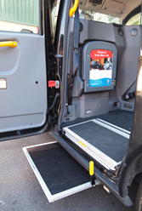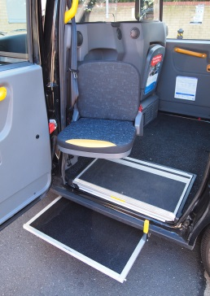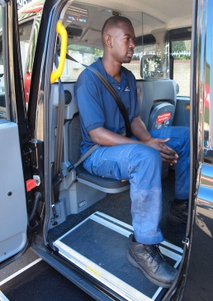
Know your Customers:
Always try to make eye contact with your passengers and ask them if they have any specific needs before starting the journey

Always keep a pen and paper handy – this can help you communicate more effectively with passengers who have hearing or speech impairments

Always offer an arm to passengers who seem to be unsteady on their feet and bring to their attention the other assistance devices fitted to your taxi such as the grab handles and swivel seat and step

TX step in position
TX1/2/4
TX swivel seat in position (ensure it locks into place)
- HIGH VISIBILITY GRAB HANDLES are provided for the passenger’s convenience and safety. Always offer their use to the customer who would benefit from using them when boarding or alighting the taxi

- LOW FLOOR LIGHTING can assist visually impaired customers and are well featured on modern taxis

- HEARING AID INDUCTION LOOPS are fitted to most modern taxis – alert your passenger that this is fitted to assist their communication with you
Use handles and assist customer into seat
Secure seat into position and ensure seatbelts are used

