Meeting Notes
Social Work Apprenticeships, London Region Event
Tricia Pereira - Principal Social Worker
London ADASS Practitioner Development Lead

Introduction
The introduction of the Apprenticeship Levy created the opportunity to explore alternative routes into social work qualification and the development of trailblazer apprenticeship standards.
In preparation of the delivery of the Social work Apprenticeship an awareness, raising event was and hosted by London Councils in collaboration with the LGA, London ADASS, and Skills for Care.
Following this successful event, Employers requested a follow up session to explore the potential for delivering the Social Worker Apprenticeship across the London region, from September 2019.
LondonADASS, London Councils, and Skills for Care hosted the event on 16th January. As the apprenticeship programme is employer led, the session aimed to explore the following from the employer’s perspective
- Developing the content of an apprenticeship program with focus on Key knowledge, theory, skill development, observation of practice etc. Evidence gathering.
- Selection criteria for applicants
- Initial and ongoing assessment
- Identifying work placed coach/mentor/assessors
- Delivering a successful apprenticeship scheme and collaboration across London.
- External factors key to delivery of a programme
- Procurement models- London Region/ sub regions/
Following this session, an action plan will be developed on jointly procuring the Social Worker Apprenticeship Standard and stimulating the market to deliver the training programme.
Attendance
The event was attended by workforce leads, PSW’s and Apprentice Leads covering both Children and Adults Workforce, from across 25 of the 33 London Councils.
Company / Council
Achieving for Children
Hestia
West London Teaching Partnership
Barnet Council
Barking and Dagenham
Bexley
Brent Council
Bromley
Camden Council
Croydon Council
Greenwich Council
Hackney Council
Haringey Council
Harrow Council
Havering Council
Hillingdon Council
Hounslow Council
Islington Council
Lambeth Council
Lewisham
Newham Council
RBKC and WCC
Richmond and Wandsworth Council
Southwark Council
Sutton
Tower Hamlets Council
Waltham Forest
Wandsworth Children's Social Care Academy
Wandsworth Council
Cross London Representation
The following councils and organisations were represented

During the session, a series of table top, fact finding exercises was carried out to capture the views of the represented councils.
Summary of responses from table top exercises below.
The overall preferred option was to develop sub regional consortium’s to;
Develop reciprocal arrangements and partnership arrangements. The attendees felt this was a great opportunity to invest and develop in existing staff in order to support their qualification and also for current social work staff in their roles of honing their skills around observation and assessment across London.
Attendees were definitely thinking positively around sub London and cross London region consortium models. And partnership working with neighbouring councils.
Exercise 1. The apprenticeship programme is for 3 years or 36 months duration with 20% off the job learning

Q1. How should the teaching component be undertaken?
Clarity was asked regarding the 20% off the job learning. Is 20% the minimum recommended time off the job learning.
What % of time can be spent as “on the job learning”?
Preferred delivery of the social work programmes was overwhelmingly, having an initial front-loaded, block induction week either quarterly or at the start of each “academic” year followed by day release throughout. During this time the HEI will “set the scene and expectations for the programme”
The block sessions seemed to be linked as a foundation for
- Introduction to good social work practice
- Introduction to certain practice frameworks or theoretical approaches such as systemic or strengths and asset based approaches. For example, focus on understanding of use of local community resource, clear understanding of how service areas work together and collaborate in an asset based approach.
Although some felt day release may not always be practical, and may have an impact on service delivery, there should be study days and time spent in the HEI setting learning.
There should be a blended approach to learning using a range of interactive tools as set out below.
There should be an opportunity for shadowing and to develop experiential learning.
HEI’s to co-opt Practice educators in order for them to capture the “learning on the job” element and to undertake the professional role of assessor
The creation of sub regional consortium’s would enable;
Develop and deliver a programme of peer group reflective sessions for apprenticeships from across the boroughs
Developing reciprocal arrangements and partnership arrangements so that learning and shadowing can be shared across councils.
Q2. What tools and resources should we use?
A range of creative blended learning programmes were discussed and recorded including
- Seminars and lectures
- Facilitated eLearning sessions and webinars (use of interactive technology)
- Podcasts
- Live broadcasts across sites.
- Access to HEI’s online learning systems to develop partnerships with research bodies e.g. Ripfa / Rip, Community Care Inform,
- Critical reflection logs
- Peer learning or action learning sets / apprenticeship peer support groups
- Use of WhatsApp and Facebook amongst other methods.
- Enrichment days - sharing best practice.
- Experiential learning
- Role Play
- Service user involvement
- Learning from the NAASS and ASYE approach / model may be useful
- Learning from the Hackney Model?
- Learning from the Open University model
Learning methods should be creative, appropriate and of good quality. Assessment of the teaching should be rigorous more so than traditional methods

Q. 3 Employer involvement in programme delivery –
Employers should be involved in the delivery of training, by identified, and recognised staff in specific roles so that the approach is consistent and there is clarity. Avoid staff members feeling “dumped on”
Employers should be involved in identifying the support and learning the apprentice may require possibly by using an appraisal type approach.
Utilise the knowledge and skills of practice experts (experienced social workers) in certain areas to work alongside lectures to deliver lectures within the HEI’s. This should complement formal university, theoretical lectures on the foundations of social work. Academics into practice type programme (teaching partnerships) may be a useful model, for academics going into the workplace.
Employers with the HEI’s should scope out the areas where practice experts would be most beneficial and useful to compliment the HEI delivery of lectures and sessions
Reflective sessions must be purposeful
Employers should be involved in mapping evidence gathering against the PCF and KSS
Q.4 Should the delivery be at HEI site or in neutral venue? What is your rationale?
Feedback stated that, whilst holding learning sessions within the university setting, would promote the learning experience of undertaking a degree. A mixture of learning in the workplace and attending HEI was the most preferred option.
Although it was recognised that hosting some sessions within the workplace may be beneficial and will add an element of flexibility, room bookings and co-ordination can be very challenging.
There was a clear expectation that the HEI should undertake regular work place visits.

Q.5 Preferred start times and number of cohorts each year?
Employers are concerned with the underspend of the Levy and the money being recouped. Ideally, a September start date was most preferable. However, it was felt that a flexible start date of March / April 2020 was more realistic and would fit in with the fiscal year.
There was a suggestion of two options of start dates Spring and Autumn.
Exercise 2. Recruitment

Q.6 What selection criteria should we follow?
A fair and sound selection process should be adopted by each council with the inclusion of “Citizens” or “People with Lived Experience” and the HEI’s
Avoid having two separate selection processes –one for the workplace and one for HEI
Ideally, there should be one process, that incorporate the employers needs and the HEI’s requirements.
Please see diagram 1 below
- Each individual council or consortium should host;
- Information / Briefing sessions
- Expression of interest submissions
- Recruitment days in conjunction with HEI

Assessment sessions – (Learn from step up programs) consisting of different exercises for different groups of candidates, such as role play, young people and people with lived experience on the panels, addressing qualities, motivation, initiative, values and leadership.
Consideration of candidates being “promised” a place on the Degree, due to length of working for the council and not on aptitude and potential.
Consideration of which service area or team can support the apprenticeship model.

Q.7 Whom will your borough enable to apply and how will this be communicated?
The majority of apprenticeship opportunities will initially be offered to existing staff within the local authority.
There was discussion around candidates who already hold a degree in another field, it was felt that they could not be excluded from taking up the apprenticeship programme. However, it was acknowledged that people who may make the best use of apprenticeship opportunities are those without a degree already. Therefore advice and options will be provided to those who already hold a BA.
Information about the apprenticeships to be shared via the councils own communication strategy or across the consortium e.g.
- Using both Internal and External comms
- News letters
- Bulletins
- Senior Leaders Emails
- Drop in sessions
- Workforce development plans
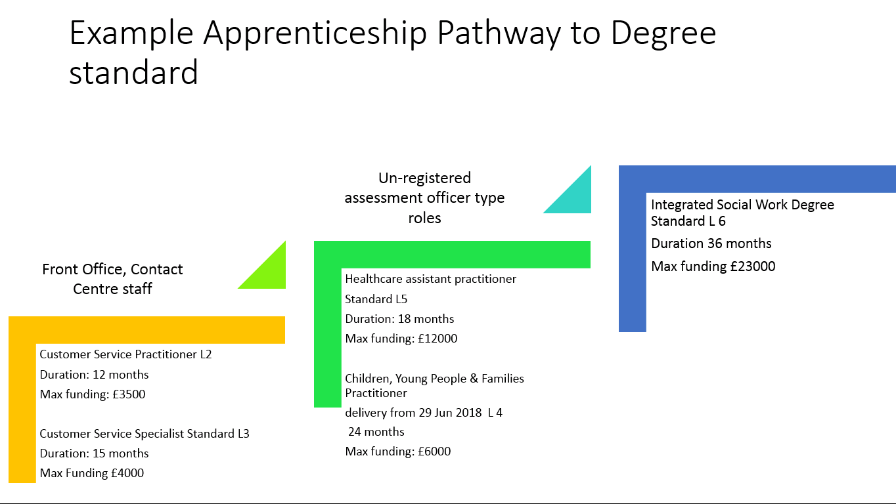
A clear organisational message, to be sent out promoting the apprenticeship opportunities and linking it with a career pathway. For example, Diagram 2 below
Examples of suggested apprenticeship standard suitable for each role; list not exhaustive.
Q.8 How can we assess someone’s potential and readiness?
- Developing a career pathway to support progression - Mapping jobs descriptions and roles against ability to deliver.
- Undertaking competency-based assessment as part of career development and taking consideration of previous social care experience
- Assessing the candidate’s ethics and value base, by using group presentations or group scenario discussions.
Using the following systems.
- Supervision
- Appraisal system
- CPD audits
- External recruitment process

Q.9 Are feeder / pre- programme or access course needed
See Diagram 2
- Access or Gateway courses may be necessary as part of the overall career pathway.
- Courses should be relevant and linked to social work or Health and Social care such as NVQ/QCF/ Apprenticeship Standard Level 2, 3, 4, and 5 for children and adults.
- Shadowing opportunities are also beneficial as preparation
Exercise 3. Key things for consideration

Q.10 Who should assess which aspects of the apprenticeship?
- Assessments should be ongoing from Year 1 of study, developing a portfolio model.
- Assessment process should Incorporate the PCF - Learners should be assessed and measured against the PCF at point of entry, through to readiness to practice.
- Practice educator role is seen as pivotal.
- The PE role can be utilised from the start – i.e. during the recruitment and Interview assessment
- The role of the PE is to enable learning of others, delver reflective supervision.
- Other roles can also be utilised as part of the ongoing assessment and delivery of learning, such as line supervisor and / or aspiring manager, team members, partner agencies, and HEI members
- Consideration of the academic element e.g. Study Leave and time out for exams

Q.11 Would any Practice Assessors need to be paid or could it be incorporated into existing roles?
The Practice Educator Role seems a natural one to undertake the delivery and assessment of the apprenticeship programme in the workplace.
Practice educators currently receive an honorarium for students on placement. Could a similar arrangement be made under the apprenticeship arrangements?
There may be dedicated roles such as Advanced Practitioner who are also PE qualified, and this work could be incorporated into their work role.
- The HEI’s can develop accredited courses for experienced Social Workers to develop assessment skills.
- A bespoke course to be delivered by HEI on delivering apprenticeship assessments. This is separate to the PEPS modules.
- Practice Educators can deliver workshops and seminars both within the HEI and at local level within their organisation (Teaching Partnership Teaching Consultant Role)
- Assignments to be set and assessed be assessed and by the HEI
- Day to Day practice to observed and signed off by Line Manager / supervisor
Q. 12 Would LA staff be willing to be seconded to the HEI to do the assessment if needed?
This is to be explored with the HEI’s. Within teaching partnerships some staff undertaking the Teaching Consultant role are currently released to deliver learning.
If social workers are to deliver learning, payment will need to be negotiated with the HEI’s out of the apprenticeship Levey.

Q. 13 What contribution towards assessment cost should HEI’s be asked to give LA’s?
This will need to be negotiated with the HEI’s.
The apprenticeship standard is funded less than traditional route.
This depends on the role of the practice educator, the work that they will be undertaking and the number of apprentices they are working with.

Q. 14 Should assessment be carried out on a borough basis or across partnerships?
This is dependent on the commissioning model
The option to have flexibility of both options would be useful. Cross borough reciprocal arrangements for assessing workers would be a useful and may beneficial to avoiding bias and adding a robust quality assurance mechanism.
Need to consider logistics and travel time etc.

Q. 15 Who should undertake the mentoring / coaching – operating within each individual borough only or cross partnership based?
Practice Educator role is likely to take this up. This could be a cross borough initiative in conjunction with the HEI’s

Further questions from Table Top discussions
Each table had a page to record further questions and solutions. We had several questions with no recorded solutions.
- Thinking needs to be done around the apprentice ship role /contracts / employment conditions / probation period.
- Do apprentices need to do placements if so, how long?
- Is there possibility for HEI's to provide funding for support within the employer? Similar to the placement fee.
- What will happen to any apprentice who goes on long-term sick leave? Maternity Leave? Wants to drop out/ delay? Personal circumstances changed/ support for failing apprentices etc.
- What if Someone is performing well academically but there are practice issues?
- Programmes need to allow apprentices space to take annual leave!
- Available to part time staff?
- How will we ensure good information sharing across HEI and employers - including apprenticeship, lead, manager, tutor, etc!
- Can an organisation join a Consortium after procurement?

