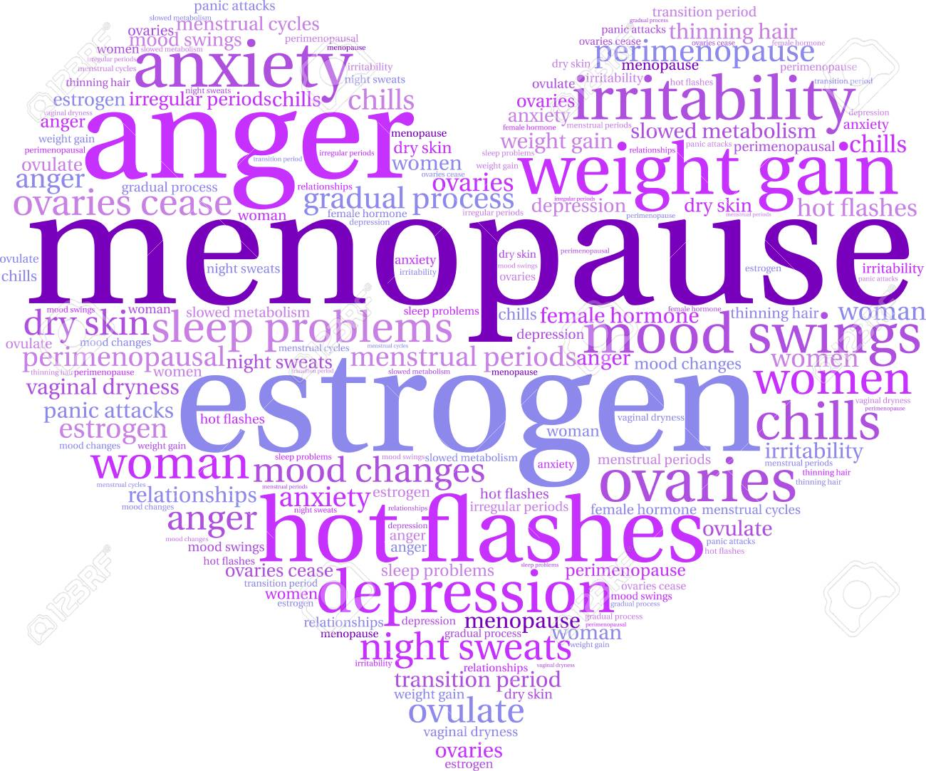
The Menopause at Work Policy

Introduction
Menopause, or, sometimes referred to as ‘the change’ is rarely discussed in the workplace. This is despite women making up almost half the workforce and there are an estimated 3.5million women over the age of fifty (50) currently in work.
These numbers will rise as the state retirement age for women increases.
Menopause typically occurs between 45 and 55 years of age, marked by changes in the hormones and the ending of menstruation. On average, most symptoms last around 4 years from your last period. However, around 1 in every 10 women experience them for up to 12 years. Some women will suffer no or variable symptoms.
People from the non-binary, transgender and intersex communities may also experience menopausal symptoms. Due to a variety of factors, the experience of the menopause may be different for those among these communities.
RBKC is committed to adapting our approach to workplace wellbeing to be considerate of all cultural and demographic differences within our workforce and take the health and wellbeing of the people who work for us seriously.
This means that the Council wants all employees to understand menopause and that it is no longer considered a ‘taboo’ subject. Menopausal employees should feel confident and comfortable to discuss any related health problems with their line manager, Human Resources, the Employee Assistance Programme (EAP), Occupational Health, (OH) and for necessary support to be in place. Employees must also be assured that any discussions will be treated confidentially.
Definitions
Perimenopause is the time leading up to the menopause when a woman may start to experience changes associated with Menopause.
Perimenopause varies greatly from one woman to the next. The average duration is three to four years, although it can last just a few months or extend as long as a decade. Some women feel buffeted by hot flashes and wiped out by heavy periods; many have no bothersome symptoms. Periods may end more or less abruptly for some, while others may menstruate erratically for years.
Menopause is when a woman stops having periods and is no longer able to get pregnant naturally. Periods usually start to become less frequent over a few months or years before they stop altogether. Sometimes they can stop suddenly.
The menopause is a natural part of ageing that usually occurs between 45 and 55 years of age, as a woman's oestrogen levels decline. In the UK, the average age for a woman to reach the menopause is 51.
However, around 1 in 100 women experience the menopause before 40 years of age. This is known as premature menopause or premature ovarian insufficiency.
Postmenopause is the time after menopause has occurred, starting when a woman has not had a period for twelve consecutive months.
During these years, oestrogen levels decline before periods stop. It is best described as a ‘transition’ rather than a one-off event.
Symptoms
Symptoms can manifest both physical and psychologically, but not exhaustively or exclusively.
Symptoms may not be experienced on an ongoing basis and can include;
- Hot flushes (brief and sudden surges of hear usually felt in the face, neck and chest)
- Palpatations (heartbeats that become more noticeable)
- Headaches
- Weight gain
- Night sweats (hot flushes that happen during the night)
- Sleep disturbance that can make people feel tired and irritable
- Fatigue
- Muscle and joint stiffness, aches and pains
- Skin changes (dryness, acne, general itchiness)
- Need to pass urine more often and recurrent urinary tract infections (UTI’s) including cystitis
- Heavy, irregular periods
- Psychological issues such as mood disturbance, poor concentration, anxiety and/or depression, panic attacks, loss of confidence and reduced concentration
- Reduced sex drive
Supportive Approach
The menopause can impact upon a number of areas of an employee’s wellbeing and performance. This could be manifested in terms of attendance and performance. It is important to understand the root cause of this before any action is considered.
We, as an employer have a legal duty to make suitable and sufficient assessment of any workplace risks to the health and safety of our employees.
Often making simple changes by having open and honest discussions can be all that is needed to support women during the menopause, recognising that every woman experiences it differently.
Risk assessments should consider the specific needs of menopausal women and ensure that their working environment will not make their symptoms worse.
The use of The Council’s flexible working and working together policies should be considered, along with the requirements of the role, (IE a front line role and office based role will have different considerations) when thinking about what supportive mechanisms can be put in place for employees experiencing menopausal symptoms, along with practical interventions such as:
Sleep disruption and/or night sweats
- Recognise that someone may need to start work later if they’ve had a difficult night or if symptoms persist, take more short-term absence.
- Consider a change to shift patterns or the ability to swap shifts on a temporary basis.
- Agree that someone can work from home on an ad-hoc basis if they had a tough night.
Hot flushes and/or daytime sweats
- Look at ways to cool the working environment, for example provide a fan, allow employee to sit near a window or blower
- Provide easy access to cold drinking water and toilets
- Adapt uniforms to improve comfort
- Limit the time wearing personal protective equipment (PPE) such as face masks
Heavy or irregular periods
- Provide easy access to toilet facilities
- Allow for more frequent breaks to go to the toilet
- Allow someone to temporarily work from home if they have very heavy bleeding
- Make it easy to request extra uniforms if needed
- Be prepared that an employee may need to go home unexpectedly
Headaches and fatigue
- Consider a temporary adjustment to someone’s work duties
- Provide access to a quiet area
- Offer easy access to drinking water to take medication and allow regular breaks
Muscular aches, and bone and joint pain
- Make any necessary temporary adjustments through review of risk assessments and work schedules
- Allow to move around, or, stay mobile if that helps
Psychological issues
(for example loss of confidence, poor concentration, anxiety etc.,)
- Encourage discussion at one to ones
- Remember and discuss the services of Occupational Health and EAP
- Discuss possible work adjustments to tasks and duties which are proving to be challenging
- Identify a supportive colleague to be a ‘buddy’ to talk away from the work area
- Have agreed ‘uninterrupted/protected’ time to concentrate on work
- Discuss external support and treatment available (GP etc.,) and be accommodating if time off for appointments is required
- Carry out a stress risk assessment and agree upon a mutually agreeable support plan which is regularly reviewed
Roles and Responsibilities
For employees:
- Try to be open and honest in conversations with managers, HR and Occupational Health
- Take personal responsibility to look after their own health
- If you are unable to speak to your line manager, discuss your needs with HR, or if you’re a member of a Union, your Trade Rep.
- Seek suitable external help and advice to discuss treatment options (E.G NHS, menopause clinic)
- Contribute to a respectful and productive working environment
- Be willing to help and support your colleagues

Line Managers
- Familiarise yourself with the Menopause Policy and Guidance
- Be ready and willing to have open discussions about menopause, appreciating the personal nature of the conversation, treating the discussion sensitively and professionally
- Record adjustments when agreed, actions to be implemented and when relevant, timelines
- Sensitively treat and manage any menopause related sick absence
- Ensure an ongoing dialogue and review dates
- Ensure that all agreed adjustments are adhered to
- Where adjustments are unsuccessful, or if symptoms are proving more problematic, the Line Manager may:
  - Discuss a referral to Occupational Health for further advice
  - Refer the employee to Occupational Health
  - Review Occupational Health advice and implement any recommendations where reasonably practical
  - Update the action plan and continue to review

This policy should be read in conjunction with the following policies and documents:

- Dignity at Work Policy
- Working Together Policy
- Flexible Working Policy
- Risk Assessments
- Menopause FAQ’s and Guidance

