FLEXIBLE RETIREMENT POLICY

Introduction:

A key objective for the Council’s Human Resources strategy is to provide a sustainable workforce and address the issue of an ageing workforce. This policy aims to enable those who no longer wish to remain part of the workforce to leave with dignity and to ensure the continuity of services through a planned and flexible approach to retirement that will facilitate the transfer of knowledge and experience to others within the organisational hierarchy.

What is Flexible Retirement?
Flexible retirement is the ability for an employee to draw their pension at the same time as being able to remain as an employee of the Council, provided there is a reduction in their grade or hours or both. Where an employee is 55 years of age or older and has at least three months total membership in the Local Government Pension Scheme ('LGPS'), he/she may be eligible for flexible retirement, subject to the Councils consent and specific criteria.

Background

1) Her Majesty's Revenue and Customs (HMRC) amended its overriding rules for all pension schemes from 6 April 2006, allowing scheme members to receive their pension benefits while continuing in employment.

2) The Local Government Pension Scheme (LGPS) regulations were amended to permit the immediate payment of pension benefits, at the employers’ consent, where a scheme member from age 55 reduces his/her hours or moves to a lower grade even though the scheme member has not retired from employment and continues to build up benefits in the Scheme.

3) In circumstances where an employee’s pensionable service does not satisfy the ’85 year rule’ (i.e. the aggregate of age plus pensionable service does not equate to 85 years), then any pension benefits placed into payment would be subject to a permanent actuarial reduction of pension and lump sum.

The principles that underpin the policy are as follows:

- Flexible retirement will only be considered as part of a planned strategy for reducing the workforce.

- All staff who are of an age to access their pension will have a right to apply for flexible retirement.

- All requests will be considered but they will not be agreed unless there is a clear business case that it is in the interests of the efficient delivery of the service.

- All decisions must be recommended by the service Director and endorsed by the Director of Finance, Resources and Customer Services in consultation with the Cabinet Member for Finance and Property (to ensure that the proposal is financially viable).

- There is no right of appeal against decisions not to grant flexible retirement.

- Employees employed on a flexible retirement basis will not be entitled to redundancy benefits at the end of their new contract.

- In the event that the employee’s post becomes at risk of redundancy during the phased retirement period, due to unforeseen circumstances (such as a departmental / corporate restructure), the following considerations will apply :-

- Where there is a supporting business case, consideration will be given as to whether the post can be accommodated in the new structure until the end of the flexible retirement period.

- Where there is no strong business case to continue the post to the end of the flexible retirement period, the employee may choose to compete to retain a post in the new structure.* If they are unsuccessful in securing a post, we will seek to redeploy them into an alternative suitable post for the remainder of their flexible retirement period and transfer the terms across. If this is not possible, they will be entitled to notice of termination on the grounds of redundancy and any associated redundancy benefits applicable

- Employees employed on a flexible retirement basis will not be eligible to apply or be appointed to other vacancies within the Council during their flexible retirement period, except in the scenario in 7 above.

*This would need to be a post which fulfils the criteria of the original flexible retirement agreement with regard to hours / grade.

Regulations
This policy is formulated under the Local Government Pension Scheme (Benefits, Membership and Contributions) Regulations 2007 and the Local Government Pension Scheme (Administration) Regulations 2008.

Benefits of the policy

To provide a sustainable workforce by:

a) aiding succession planning by enabling a gradual transfer of skills from experienced employees to new recruits.

b) enabling employees to effect a smoother transition from work into retirement by removing the cliff edge that currently exists.

c) providing Enfield with an alternative way of reducing overall cost of the workforce through voluntary rather than compulsory means.

Eligibility: criteria

Offers of flexible retirement will only be considered where:

- the employee has skills and knowledge which need to be transferred to other staff before he / she retires
- it is mutually beneficial for the employee and the Council
- the flexible retirement meets an identified business need.
- the employee must be able to draw on their pension benefits

The following restrictions will apply to flexible retirement

- The employee's reduction in grade must be by at least two grades OR
- The employee’s reduction in working hours must be at least 50% of the previous hours worked – a reduction of 40% of previous hours worked may be agreed for an initial period of up to one month
- The employee's new contract must not exceed a period of two years
- The employee must tender their notice of their intention to resign at the end of the fixed term contract.

Flexible Retirement Terms

Release of retirement benefits with no waiving of any applicable actuarial reduction - the actuarial reduction is the amount the Government Actuary requires the pension and lump sum (if applicable) to be reduced when paid before the earlier of the 65th birthday or the 85 year rule date (subject to the Local Government Pension Scheme transitional provisions). Where the 85 year rule applies the actuarial reduction will not apply.

Process

Process

- Where there is a business need the Head of Service may opt to invite employees to consider the option of flexible retirement. In these circumstances the employee should raise the possibility of flexible retirement informally with their Head of Service. (If the employee is a Head of Service they should raise it with their line manager).

- If there is a favourable response the employee should complete and sign forms 1FR and 2FR which should be submitted to the Head of Service. Form 2FR should be counter signed by the Head of Service and submitted to the Pensions Department.

- When the Head of Service has received back Form 2FR from the Pensions Department they should meet with the employee to discuss the implications.

- If the Head of Service cannot agree then Form 3FR should be sent to the employee.

- If the Head of Service supports the request they should sign and submit Form 1FR to the Director, detailing proposals/business case and the net savings for the Council.

- If the Director agrees, Form 1FR should be signed and sent to the Director of Finance, Resources and Customer Services for verification of the benefits, adjustments of the budgets and authorisation.

- If the Director of Finance, Resources and Customer Services does not agree, Form 4FR should be sent to the employee.

- If the Director of Finance, Resources and Customer Services in consultation with the Cabinet Member for Finance and Property authorises the request, Form 5FR should be sent to the employee for signature.

- Where Flexible Retirement is agreed with the Director of Finance, Resources & Customer Services the Head of Service / Manager then completes Form 7FR – Flexible Retirement - Action Sheet and ensures that required details of the flexible retirement arrangement are provided, and that the completed form is sent, with the forms listed on the Action Sheet, to the HR Business Support Team, Payroll Services and the Pensions Team.

- If the fixed term contract is for a period of less than 2 years the employee may request an extension to the fixed term contract. The Head of Service should discuss this with the department’s Director. If this is agreed the Director of Finance’s authority for the extension must be obtained and then extension Form 6FR prepared and sent to the employee to sign. The signed form should be sent to HR Business Support, Payroll and Pensions to note and action extension to contract.

- The decision of the Director of Finance, Resources and Customer Services is final.

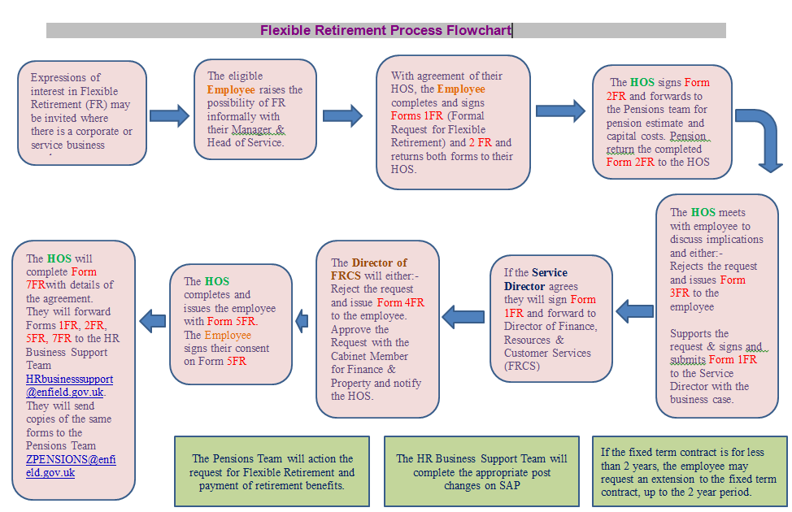

Review:

Human Resources will review this policy on an annual basis.
FORM 1FR

Flexible Retirement Application Form

PRIVATE & CONFIDENTIAL

This form should be used to make a formal request for a flexible retirement.

Personal Details:

Name: | Payroll Number:
Date of Birth: | Job Title:
Department: | Team/Section/Unit:

I would like to apply for a flexible retirement option.

Please describe the working arrangement you would like in the future including days, hours, role, times of work etc.

Please note that your option must include a reduction in grade by at least two grades or a reduction of 50% of your previous working hours.

For full consideration to be given to your application please outline the following:

- What effect your proposed change will have on your service/team
- Your opinions on how you think this should be dealt with
- Any other matters you wish to be taken into consideration

If agreed, when would you like the requested work arrangement to commence:

Declaration

- I have a minimum of 3 months total membership in, or transfer value to, the LGPS.
- I am over 55 years of age.
- I understand that the change requested above will be implemented until the end of my new contract.
- I agree to seek independent financial advice on the effect of this change on my pension benefits.
- I can confirm that if my request for flexible retirement is granted I will tender my notice of my intention to resign at the end of the new contract.

Signed:

Date: __________________ _

Please note that an application does not guarantee that your request will be granted.

Business case in support of the Flexible Retirement.

Head of Service …………………………………….…… Date ……………………
Signed

Director ………………………………………………….. Date ……………………
Signed

Authorised by Director:
Finance, Resources & Customer Services …………………………… Date ……………………...
Signed

PLEASE APPEND FORM 2FR DETAILING COSTS OF RETIREMENT

FORM 2FR

Estimate of Flexible Retirement Benefits

CONFIDENTIAL

Employees should complete this form and send it to their Head of Service who will counter sign it and forward to the Pensions Department at:

Third Floor,
Civic Centre,
Silver Street,
Enfield,
Mddx, EN1 3XA

Please allow 10 working days for the figures to be provided.

Name: | Payroll Number:
Date of Birth: | Job Title:
Department: | Team/Section/Unit:

Please could you provide me with pension benefits figures, as I am considering
flexible retirement and my proposed last day of service in my current contract will be
/ / [insert date]
Signed: ________________________________________ Date: _______________

I have agreed in principle that the above employee can apply for flexible retirement
Signed ____________________________Head of Service Date :_____________________

For Pension Department use only

Type of retirement Flexible Retirement

Pension

Funded Benefits £

Less Reduction £

Capital Cost £

Total Annual Pension Payable £

Total Pension Lump Sum Payable £

Prepared by:

Date:
FORM 3FR

Flexible Retirement Rejection Letter from Head of Service

[Title, initial and last name of employee]
[Address 1]
[Address 2]
[Address 3]
[Postcode]

Dear [Title and last name of employee]

Flexible Retirement Application

Further to our meeting on ……………………………………… I regret to inform you that I am unable to support your request to be considered for Flexible Retirement. The reason for this is as follows:

Yours sincerely

[Name of line manager]
[Job title]

FORM 4FR

Flexible Retirement Rejection Letter from
Director of Finance, Resources & Customer Services

[Title, initial and last name of employee]
[Address 1]
[Address 2]
[Address 3]
[Postcode]

Dear [Title and last name of employee]

Flexible Retirement Application

I am writing to inform you of the outcome of your request for flexible retirement

I regret to inform you that your request for flexible retirement has not been agreed for the following reasons:

[insert details]

Please note there is no right of appeal and therefore this decision is final.

Yours sincerely

Director
Finance, Resources & Customer Services

FORM 5FR

Outcome of Flexible Retirement
Important Note:
The duration of the Flexible Retirement contract
and any extension/s thereto may not exceed two years in total

[Name]
[Address]
[Address]
[Address]

Dear ,

I am pleased to inform you that the Director of Finance, Resources & Customer Services has agreed to your request for Flexible Retirement received on …………………………subject to the conditions outlined below.

With effect from…………………………….. until ……………..…………………… you will be employed on:

Grade: ………..
Hours: ……….

With effect from ……………….……….. you will be granted retirement benefits under Regulation 18 of the Local Government Pension Scheme ( Benefits, Membership and Contributions ) Regulations 2007.

With effect from …………………….. you will retire from the Council’s employment.

If you agree to these new contractual arrangements please complete and sign the section below and return this letter to me by no later than …………………………

Yours sincerely

Head of Service
-----------------------------------------------------------------------------------------------------------------------------

I can confirm that I accept the contractual terms detailed above and hereby give you notice that I will resign from the service of Enfield Council on …………………………..

Signed:

Name:
Date:
FORM 6FR

Extension of Flexible Retirement Contract
Important Note:
The duration of the Flexible Retirement contract
and any extension/s thereto may not exceed two years in total

[Name]
[Address]
[Address]
[Address]

Dear

Further to discussions regarding your Flexible Retirement I am pleased to inform you that the Director of Finance, Resources & Customer Services has agreed to your request for an extension of your Flexible Retirement contract until…………………, subject to the conditions outlined below.

Grade: ………..
Hours: ……….
Working Pattern………

With effect from ……………………..you will retire from the Council’s employment.

All other terms and conditions of your employment remain unaltered.

To confirm your agreement to these contractual arrangements please complete and sign the section below and return this letter to me by no later than …………………………

Yours sincerely

Head of Service
-----------------------------------------------------------------------------------------------------------------------------

I can confirm that I accept the contractual terms detailed above and hereby give you notice of my resignation from the service of Enfield Council with effect from …………………………..

Signed:

Name:

Date:
FORM 7FR

FLEXIBLE RETIREMENT – ACTION SHEET

Management:

Employee’s Name:

Employee’s Pay Number:

Employee’s Current Post Number:

Important notes:

- Minimum Flexible Retirement Contract period permissible is 3 months and the maximum period is two years.
- Reduction in grades: where this applies this must be by two grades
- Reduction in hours: where this applies this must be by 50% (40% may be agreed for 1st month)

Complete as appropriate:

Reduction in Grades: The above-named is taking Flexible Retirement and a two-grade reduction from grade ………to ………will apply with effect from ……….and ending on ………, which shall be the last day of this fixed term contract.

Job Title: The name of the post currently entitled ………should be changed to ……… and the new post number is ………

Reduction in Hours: The above-named is taking Flexible Retirement and reducing his / her hours to ………with effect from ………ending on ………, which shall be the last day of this fixed term contract. His / her working pattern will be ……… (NB: If shifts / rotas are involved please complete a work schedule form).

Extension of Existing Flexible Retirement Contract: A request for an extension to the existing Flexible Retirement contract until ……… has been approved, which shall be the last day of this fixed term contract. I confirm that the original contract and extension/s thereto do not exceed two years in total. The following apply to this contract extension:

Grade from ………to ………
Working Hours from ………to ………
Working Pattern: ………
(NB: If shifts / rotas are involved please complete a work schedule form).

Please indicate below that you have carried out the following actions:

- Provided the information requested above regarding grade, working hours, working pattern and contract start and finish dates

Sent the following copied documents to the Payroll Team & Pensions Team:
  - Application Form – 1FR
  - Pensions Estimate – 2FR
  - Employee’s signed Acceptance Form – 5FR
  - Extension to Flexible Retirement Contract – 6FR (if applicable)
Sent the originals of the above documents to the HR Business Support Team

Payroll & Pensions Teams:

- Please action the attached application for flexible retirement and payment of retirement benefits

HR Business Support Team:

- SAP - Please action the flexible retirement changes using SAP process notes for Change of Post Action – reason of Flexible Retirement :

  - File documents

